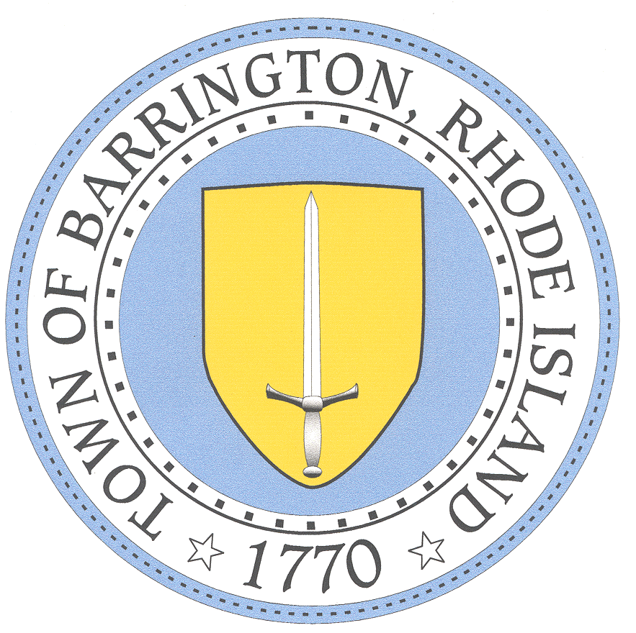

BARRINGTON PUBLIC SCHOOLS www.barringtonschools.org

283 County Road, P.O. Box 95 Barrington, Rhode Island 02806 Tel: 401-245-5000 Fax: 401-245-5003

Michael B. Messore, III
Superintendent

Paula A. Dillon, Ed.D. Douglas E. Fiore
Assistant Superintendent for Curriculum & Instruction Director of Administration & Finance
David J. Burrows Kristen C. Matthes
Director of Technology Director of Pupil Personnel Services

Empowering All Students to Excel

Progress Review
Date: | School:
Student: | Grade:

Dear Parent(s)/Guardian(s):

We strive to ensure success for every student. Your child has been receiving an intervention in the area of ____
For the last 6-8 weeks. Interventions are provided as needed to all students who are not meeting expected levels of proficiency. This system of providing intervention based on individual student needs is called Response to Intervention (RTI). Your child’s teacher(s) and intervention provider have been tracking your child’s progress over time to monitor his/her successes.

After reviewing your child’s progress, your child’s teacher and intervention provider have decided to:

- Discontinue intervention because gap was closed.
- Continue intervention because it seems to be working.
- Revise or refine intervention and document changes on intervention plan.
- Refer to more intensive problem solving with a building-based problem solving team.

Please call me at _______________________ if you have any questions about this process and to address any questions or concerns you may have. We value you as a partner in ensuring ____________________________ school success.

Respectfully,

_____________________________ __________________________________

Classroom Teacher Intervention Provider
“The Barrington Public Schools does not discriminate on the basis of race, color, creed, national or ethnic origin, gender, religion, disability, age, sexual orientation, gender identity or expression, citizenship, or status as a disabled veteran, or past or present honorable military service with respect to access to, the provision of, or employment in its educational services, programs and activities, including admissions, athletics and other district programs.”

