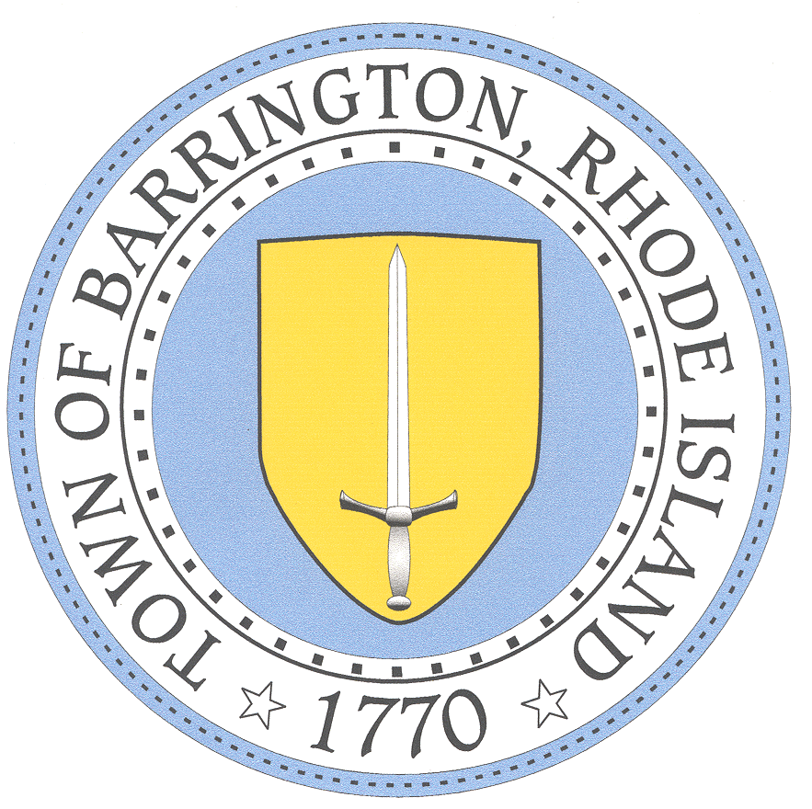

BARRINGTON PUBLIC SCHOOLS www.barringtonschools.org

283 County Road, P.O. Box 95 Barrington, Rhode Island 02806 Tel: 401-245-5000 Fax: 401-245-5003

Michael B. Messore, III
Superintendent

Paula A. Dillon, Ed.D. Douglas E. Fiore
Assistant Superintendent Director of Administration & Finance
David J. Burrows Kristen C. Matthes
Director of Technology Director of Pupil Personnel Service

Empowering All Students to Excel

Discontinue Intervention
Date: | School:
Student: | Grade:

Dear Parent(s)/Guardian(s):

We strive to ensure success for every student. Your child has been receiving an intervention in the area of ____
Interventions are provided as needed to all students who are not meeting expected levels of proficiency. This system of providing intervention based on individual student needs is called Response to Intervention (RTI). Your child’s teacher(s) and intervention provider have been tracking your child’s progress over time to monitor his/her successes.

After reviewing your child’s progress, your child’s teacher and intervention provider have decided to:

Discontinue intervention because gap was closed as evidenced by the following assessment information:

Please sign and return bottom portion of this letter. If you have any questions, please call me. We value you as a partner in ensuring your child’s school success.

Respectfully,
________________________________ ________________________________
Classroom Teacher Intervention Provider
********************************************************************************************

I have received notice that the intervention that my child____________ has been receiving has been discontinued.
- Discontinue intervention because gap has closed.

Signature of Parent/Guardian_____________________________Date_______________

The Barrington Public Schools does not discriminate on the basis of race, color, national or ethnic origin,
gender, religion, disability, age, sexual orientation, gender identity or expression, citizenship, or status as a disabled veteran, or past or present honorable military service with respect to access to, the provision of, or employment in its educational services, programs and activities, including admissions, athletics and other district programs.

